Beginning with all shows in 2011-2012 season it will be mandatory that ALL RSNC Sanctioned Event Flyers have the following (and see page 2) content, 1 thru 9, incorporated in their show flyer.

This will help contestants understand that no matter where they travel to RSNC Sanctioned events their will be consistency of how classes are advertised and run at shows around the United States.
Also, if you have this information already on your flyer when you submit it to me, it will make the process of getting your flyer posted on the website much faster, so it is a win-win for both you as a Producer and for me to get your flyer posted.
Please let me know if you have questions, Val Rodriguez, 775-397-5652, val@rsnc.us
Thanks again for your help and cooperation. (See Generic flyer on page 2)
1. Town, State
2. Ranch Sorting National Championships Sanctioned Ranch Sorting at______________
3. Date - Start Time (i.e. Books Open 8:00 am ~ Start 9:00 am)
4. FREE RSNC MEMBERSHIPS FOR 2011-2012 SEASON!!!
All new contestants will receive a FREE RSNC membership!
*Reminder: Note to Producer: All RSNC Sanctioned Events MUST offer an All-Levels Handicap, a Beginner Division or Rookie #11 HC, and at least one other division as per Producer Information Packet
5. Class name listed, fee per rider and payback (see example below)
Class Name Fee Per Rider Payback
All Levels HC $28 60%
Beginner Ranch Hand (#1 Beg Cap on Sorter) $18/$13 50%
#10 HC $28 60%
#6 HC $28 60%
#10 Masters HC $28 60%
6. *Entry Fees include a $3/entry RSNC sanctioning fee
7. ~ 5 Ride Limit ~Mandatory Draw- Pick 1 Automatically Draw 1 (You can Pick up to 4 or Draw All 5)
8. CONTACT_____________ at # _______________and/or email___________WITH ANY QUESTIONS
9. *** All info on this flyer is subject to change. ***

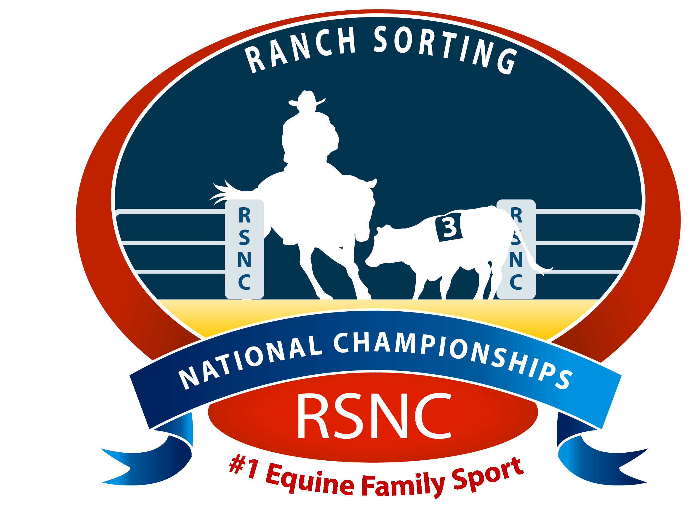
Note to Producer:
The items highlighted
in YELLOW are required for
RSNC Sanctioned Events.

Town, State

Ranch Sorting National Championships Sanctioned Ranch Sorting at the
Horseshoe Park Arena in Queen Creek, AZ
Indoor/Outdoor Arena

Date - Start Time

Add Your Personalized
Blurb Here
Qualify for the RSNC Sort For The Saddles!

Books Open:
Start :
FREE RSNC MEMBERSHIPS FOR 2011-2012 SEASON!!!
All new contestants will receive a free RSNC membership!

Note to Producer:
All RSNC Sanctioned Events MUST offer an All-Levels Handicap, a Beginner Division or Rookie #11 HC, and at least one other division
as per Producer Information Packet

Class Name Fee Per Rider Payback
All Levels HC $28 60%
Beginner Ranch Hand (#1 Beg Cap on Sorter) $18/$13 50%
#10 HC $28 60%
#6 HC $28 60%
#10 Masters HC $28 60%

*Entry Fees include a $3/entry RSNC sanctioning fee
~ 5 Ride Limit ~
Mandatory Draw- Pick 1 Automatically Draw 1 (You can Pick up to 4 or Draw All 5)
Concessions?
Awards?

Location: | Directions:
Stalls available on first come first serve basis | RV Hookups available on first come first serve basis
CONTACT at # WITH ANY QUESTIONS
*** All info on this flyer is subject to change. ***

